**IAAO WORKSHOP 265: VALUING PROPERTIES WITH RENEWABLE ENERGY RESOURCES**

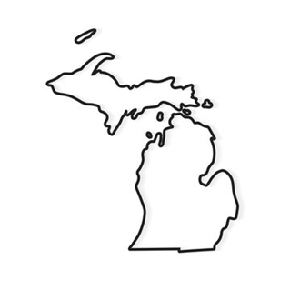 **Sponsored By: The Northeast Michigan Assessor’s Association**

in partnership with the International Association of Assessing Officers,

NEMAA will be sponsoring:

**IAAO WORKSHOP 265: VALUING PROPERTIES WITH RENEWABLE ENERGY RESOURCES**

This course has been approved for 15 hours of continuing Education by the STC

**Course Objectives:**

* Define and recall key facts about renewable energy.
* List and describe different forms of renewable energy sources.
* Explain factors that influence consumers’ decisions regarding the adoption of renewable energy.
* Explain the assessor's responsibility in valuing properties with renewable energy.
* Apply key steps in each of the three valuation approaches.
* Recognize the challenges involved with valuing properties containing renewable energy equipment.
* Apply paired sales analysis to determine contributory value of solar panels throughout the case study
* jurisdiction.

**Presented by:** Lisa Hobart, CAE, PPS, FIAAO, ASA, MMAO

**When:** Wednesday May 21, 22 & 23, 2025 Classes start at 8:30am

**Cost:** $350 per person NEMAA Member. Includes snacks, beverages

$500 per person non-NEMAA Member. Includes snacks, Beverages

Lunch each day will be on your own.

**Where:** Forward Conference Center 2980 Cook Rd.

West Branch Mi. 48661

Class materials will be provided at the class

***REGISTRATION DEADLINE May 12, 2025*** - ***Seating Limited- RSVP required­***

***PLEASE COMPLETE REGISTRATION FORM FOR EACH PERSON ATTENDING***

*************************************************************

Name: ________________________________ Phone: ____________________________

Unit: _________________________________ Email: ____________________________

Make payment to: NEMAA or Northeast Michigan Assessors Association

Mail registration with payments to:

Karie Wardynski-NEMAA

180 State Park Dr

Bay City MI, 48706

For information, please contact Randy Booth at [jrbooth2127@gmail.com](mailto:jrbooth2127@gmail.com) or 989-390-0716